



Course: Principal of Managerial Accounting Course Code: ACCT 201
Assignment one

- Please answer all the questions.

- This assignment will carry 10% from your total mark.

- Please upload your answers into portal (Hard copies will not be accepted).

- Deadline is 06/11/2015.

Q1:

Custom Metal Works Products uses a Job-order costing system. Overhead costs applied to jobs on the basis of machine hours, at the beginning of the year, management estimated that 85,000 machine-hours would be required for the period’s estimated level of production. The company also estimated $106,250 of fixed manufacturing overhead expenses for the coming period and variable manufacturing overhead of $0.75 per machine hour.

Required:

- Compute the company’s predermined overhead rate.

- Assume that during the year the company actually works only 80,000 machine-hours and incurs the following costs in the manufacturing overhead and work in process accounts:

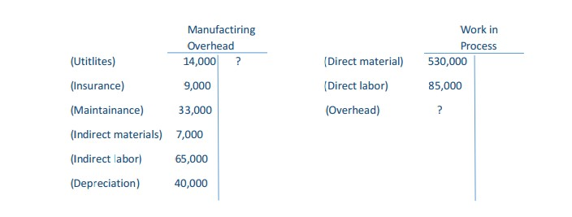

Copy the data in the T-accounts above onto your answer and compute the amount of the overhead cost that would be applied to Work in Process for the year, and make the entry in your T-accounts.

- Compute the amount of underapplied or overapplied overhead for the year, and show the balance in your Manufacturing overhead T-account. Prepare a journal entry to close out the balance in this account to cost of goods sold.

- Explain why the manufacturing overhead was underapplied or overapplied for the year.

Q2:

The CCPV Company manufactures a high – quality plastic pipe that goes through three processing stages prior to completion.

Information on work in the first department, cooking, is giving below for May:

Production data:

Pounds in process, May 1: materials 100%

Complete; conversion 90% complete ………………………………………………………………… 70,000 Pounds started into production during May ………………………………………………………. 350,000 Pounds completed and transferred to the next department …………………………….. ?
Pounds in process, May 31: material 75% complete;

Conversion 25% complete ………………………………………………………………………………….. 40,000 Cost data:
Work in process inventory, May 1:

Materials cost ……………………………………………………………………………………………………. $86,000 Conversion cost …………………………………………………………………………………………………. $36,000 Cost added during May:
Materials cost ……………………………………………………………………………………………………. $447,000

Conversion cost …………………………………………………………………………………………………. $198,000

The company uses the weighted-average method.

Required:

  - Compute the equivalent units of production.
  - Compute the costs per equivalent unit for the month.
  - Determine the cost of ending work in process inventory and of the units transferred out to the next department.
  - Prepare a cost reconciliation report for the month.

